| SCHOOL OF INFORMATION AND TECHNOLOGY | | |
| --- | --- | --- |
| NAME: | DATE PERFORMED: | /50 |
| Section: | DATE SUBMITTED: |

SYSADM1 – Setting Up Webserver

Requirement:

∙ A virtual machine running Linux and Windows OS

Task Instructions:

1. Install IIS by adding it as a role, select necessary features, include monitoring tools

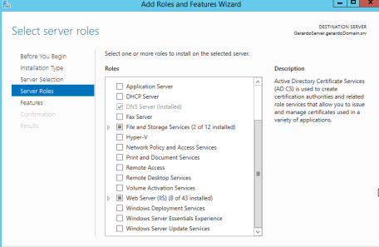

2. Create a website by opening IIS Manager

o Right-click on the server’s name and select Internet Information Services Manager. o Right-click on Sites and select Add Website.

o Enter a name, description, physical path (where your website files will reside), IP address, port, and host name.

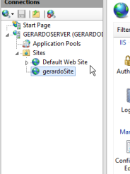

3. Configure the Website:

o Right-click on your website and select Edit.

o Set the Default Document to the name of your main HTML file >default.html

o Configure other settings as needed (e.g., SSL certificates, authentication)

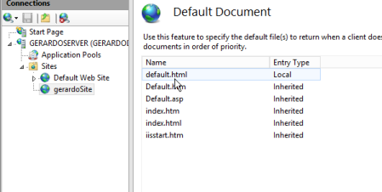Page **2** of **5**

4. Create a Web Page:

o Create an HTML file in the physical path you specified.

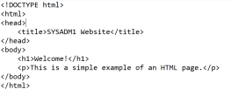

o Save it as default.html or your preferred name.

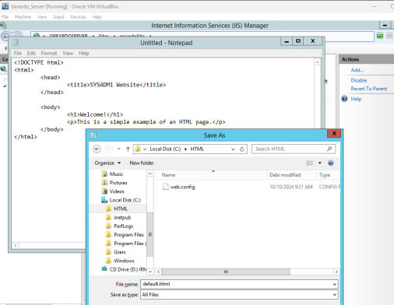Page **3** of **5**

5. Test the Web Server:

o Open a web browser and enter the URL of your website (e.g., http://localhost). o You should see your web page displayed.

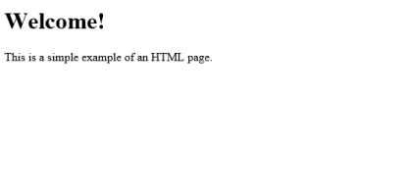Page **4** of **5**

Grading Rubric

| **Criteria** | **Points** | **Description** |
| --- | --- | --- |
| Web Server  Installation | 15 | Correctly installs IIS or another web server on the virtual machine. |
| Website  Configuration | 15 | Successfully configures the website with the correct physical path, IP address, port, and default document. |
| Successful Access | 15 | Successfully accesses the web page from the client computer using the correct URL. |
| Troubleshooting | 15 | Demonstrates ability to troubleshoot common issues, such as network connectivity problems or configuration errors. |
| Documentation | 10 | Provides clear and concise documentation of the installation, configuration, and testing process. |
| Total | /70 |  |

Page **5** of **5**